PHPExcel Developer Documentation

Contents
PHPExcel Developer Documentation 1
1. Contents 2
2. Prerequisites 3
2.1. Software requirements 3
2.2. Useful tools 3
2.2.1. OpenXML / SpreadsheetML 3
2.2.2. Frequently asked questions 3
3. Architecture 4
3.1. Schematical 4
3.2. Spreadsheet in memory 4
3.3. Readers and writers 4
4. Creating a spreadsheet 5
4.1. The PHPExcel class 5
4.2. Worksheets 5
4.3. Drawings 5
5. Performing formula calculations 6
6. Reading and writing to file 7
6.1. Excel 2007 (SpreadsheetML) file format 7
6.1.1. PHPExcel_Reader_Excel2007 7
6.1.2. PHPExcel_Writer_Excel2007 7
6.2. Serialized file format 7
6.2.1. PHPExcel_Reader_Serialized 7
6.2.2. PHPExcel_Writer_Serialized 7
7. API reference 8
7.1. Styles 8
7.2. Drawing 8

Prerequisites

Software requirements
The following software is required to develop using PHPExcel:
- PHP version 5.2 or newer
- PHP extension php_zip enabled

Useful tools
There are some tools which are very useful when developing using PHPExcel. Please refer to the PHPExcel CodePlex pages for an update version of the list below.

OpenXML / SpreadsheetML
- File format documentation
http://www.ecma-international.org/news/TC45_current_work/TC45_available_docs.htm
- Microsoft Office Compatibility Pack for Word, Excel, and PowerPoint 2007 File Formats
http://www.microsoft.com/downloads/details.aspx?familyid=941b3470-3ae9-4aee-8f43-c6bb74cd1466&displaylang=en
- OpenXML Package Explorer
http://www.codeplex.com/PackageExplorer/

Frequently asked questions
The F.A.Q. page for PHPExcel can be found on http://www.codeplex.com/PHPExcel/Wiki/View.aspx?title=FAQ&referringTitle=Requirements.

Architecture

Schematical
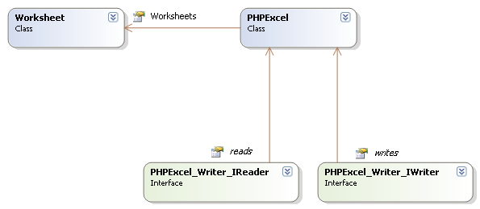

Spreadsheet in memory
PHPExcel’s architecture is built in a way that it can serve as an in-memory spreadsheet. This means that, if one would want to create a web based view of a spreadsheet which communicates with PHPExcel’s object model, he would only have to write the front-end code.

Just like desktop spreadsheet software, PHPExcel represents a spreadsheet containing one or more worksheets, which contain cells with data, formulas, images, …

Readers and writers
On its own, PHPExcel does not provide the functionality to read from or write to a persisted spreadsheet (on disk or in a database). To provide that functionality, readers and writers can be used.

By default, the PHPExcel package provides some readers and writers, including one for the Open XML spreadsheet format (a.k.a. Excel 2007 file format). You are not limited to the default readers and writers, as you are free to implement the PHPExcel_Writer_IReader and PHPExcel_Writer_IWriter interface in a custom class.

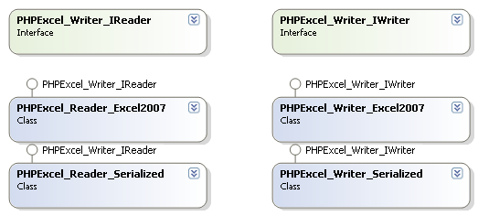

Creating a spreadsheet

The PHPExcel class
The PHPExcel class is the core of PHPExcel. It contains references to the contained worksheets, document security settings and document meta data.
TODO

Worksheets
TODO

Drawings
TODO

Performing formula calculations
As PHPExcel represents an in-memory spreadsheet, it also offers formula calculation capabilities.
TODO

Reading and writing to file
As you already know from part 3.3 Readers and writers, reading and writing to a persisted storage is not possible using the base PHPExcel classes. For this purpose, PHPExcel provides readers and writers, which are implementations of PHPExcel_Writer_IReader and PHPExcel_Writer_IWriter.

Excel 2007 (SpreadsheetML) file format
TODO

PHPExcel_Reader_Excel2007
TODO

PHPExcel_Writer_Excel2007
TODO

Serialized file format
TODO

PHPExcel_Reader_Serialized
TODO

PHPExcel_Writer_Serialized
TODO

API reference
This section describes some portions of the PHPExcel API which need examples or more clarification than provided in the generated API reference. A complete and up-to-date API reference can be found in the Documentation/API folder.

Styles
TODO

Drawing
TODO

